Project Design Phase-II
Technology Stack (Architecture & Stack)

Date | 31 January 3035
Team ID | LTVIP2025TMID32230
Project Name | SmartSDLC – AI-Enhanced Software Development Lifecycle
Maximum Marks | 4 Marks

Technical Architecture:
The Deliverable shall include the architectural diagram as below and the information as per the table1 & table 2
Example: Order processing during pandemics for offline mode
Reference: https://developer.ibm.com/patterns/ai-powered-backend-system-for-order-processing-during-pandemics/
Guidelines:
Include all the processes (As an application logic / Technology Block)
Provide infrastructural demarcation (Local / Cloud)
Indicate external interfaces (third party API’s etc.)
Indicate Data Storage components / services
Indicate interface to machine learning models (if applicable)


Table-1 : Components & Technologies:
S.No | Component | Description | Technology
 | User Interface | How user interacts with application e.g.  Web UI, Mobile App, Chatbot etc. | HTML, CSS, JavaScript / Angular Js / React Js etc.
 | Application Logic-1 | Logic for a process in the application | Java / Python
 | Application Logic-2 | Logic for a process in the application | IBM Watson STT service
 | Application Logic-3 | Logic for a process in the application | IBM Watson Assistant
 | Database | Data Type, Configurations etc. | MySQL, NoSQL, etc.
 | Cloud Database | Database Service on Cloud | IBM DB2, IBM Cloudant etc.
 | File Storage | File storage requirements | IBM Block Storage or Other Storage Service or Local Filesystem
 | External API-1 | Purpose of External API used in the application | IBM Weather API, etc.
 | External API-2 | Purpose of External API used in the application | Aadhar API, etc.
 | Machine Learning Model | Purpose of Machine Learning Model | Object Recognition Model, etc.
 | Infrastructure (Server / Cloud) | Application Deployment on Local System / Cloud  Local Server Configuration:  Cloud Server Configuration : | Local, Cloud Foundry, Kubernetes, etc.

Table-2: Application Characteristics:
S.No | Characteristics | Description | Technology
 | Open-Source Frameworks | List the open-source frameworks used | Technology of Opensource framework
 | Security Implementations | List all the security / access controls implemented, use of firewalls etc. | e.g. SHA-256, Encryptions, IAM Controls, OWASP etc.
 | Scalable Architecture | Justify the scalability of architecture (3 – tier, Micro-services) | Technology used
 | Availability | Justify the availability of application (e.g. use of load balancers, distributed servers etc.) | Technology used
 | Performance | Design consideration for the performance of the application (number of requests per sec, use of Cache, use of CDN’s) etc. | Technology used

References:
https://c4model.com/
https://developer.ibm.com/patterns/online-order-processing-system-during-pandemic/
https://www.ibm.com/cloud/architecture
https://aws.amazon.com/architecture
https://medium.com/the-internal-startup/how-to-draw-useful-technical-architecture-diagrams-2d20c9fda90d

SmartSDLC – AI-Enhanced Software Development Lifecycle
🏗 Technical Architecture Diagram
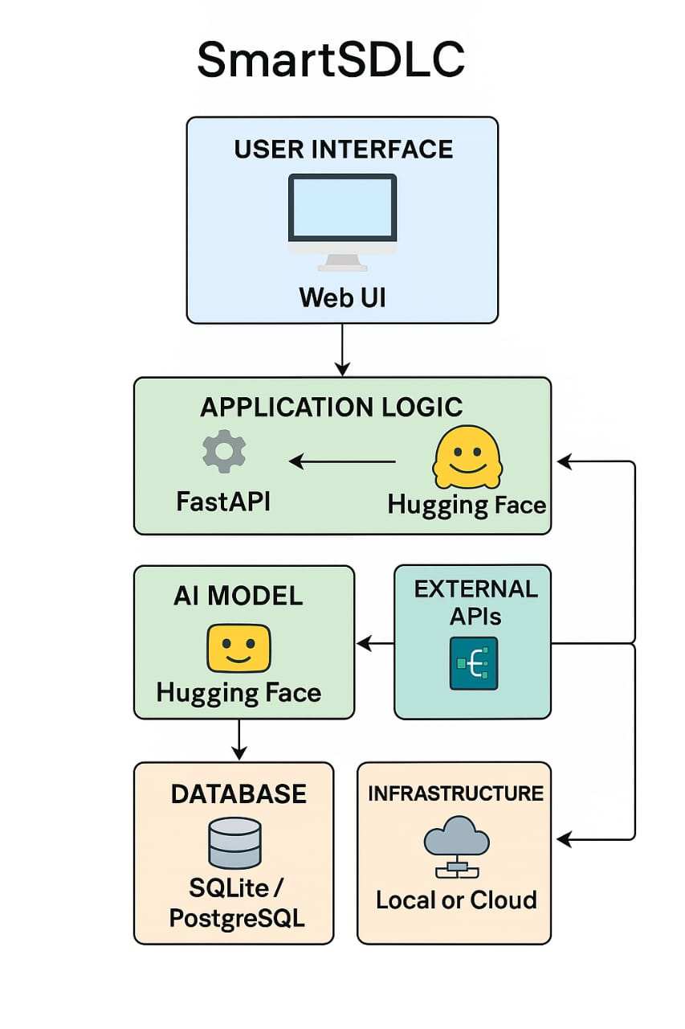
Frontend/UI Layer: User interacts through a web app (Streamlit).
Backend Logic: FastAPI handles the request-response lifecycle.
AI Models (LLMs): Hugging Face APIs process natural language for requirements extraction, code generation, and test generation.
Database: Stores uploaded documents, processed outputs, user data.
External APIs: Integration with GitHub, cloud storage, or authentication.
Infrastructure: Deployed on local systems or cloud platforms (AWS, Azure, or IBM Cloud).

🧮 Table-1: Components & Technologies
S.No Component Description Technology
1 User Interface Web UI where users upload documents and receive outputs HTML, CSS, Streamlit
2 Application Logic-1 Upload and process document Python + FastAPI
3 Application Logic-2 Extract requirements using NLP models Hugging Face Transformers
4 Application Logic-3 Generate code/test cases using AI Hugging Face GPT-style LLM
5 Database Store user data, processed content SQLite / PostgreSQL
6 Cloud Database Cloud-hosted user and file data (optional) AWS RDS / IBM Cloudant
7 File Storage Store uploaded documents Local Filesystem / AWS S3 / IBM Block Storage
8 External API-1 Model API for code generation Hugging Face Inference API
9 External API-2 Authentication APIs (OAuth, if any) Google OAuth / GitHub Login (optional)
10 Machine Learning Model NLP model for understanding SDLC content BERT / GPT-2 / CodeT5
11 Infrastructure (Server) Cloud or local deployment Localhost, AWS EC2, Render, or Streamlit Cloud

🧾 Table-2: Application Characteristics
S.No Characteristics Description Technology
1 Open-Source Frameworks Python frameworks and NLP libraries FastAPI, Streamlit, Transformers (Hugging Face)
2 Security Implementations Basic auth, input validation, API token control, secure document upload OAuth 2.0, HTTPS, SHA-256 hash, JWT

